Lab - Getting started with Prolog

The purpose of this lab is to get us started with SWI Prolog – we will look at how to add/retract facts and query the knowledge base from the command line, how to save our knowledge base to a file and run queries, and how to modify the knowledge base that we saved.

1. **Installing SWI-Prolog**

SWI Prolog is already installed on the lab computers. If you want to install it at your own computer, you can download it from

<http://www.swi-prolog.org/>

The SWI-Prolog website also includes installation notes, basic tutorials and documentation.

1. **Opening Prolog, typing at the prompt**



Locate the Prolog icon on your desktop or

open Prolog from the windows menu

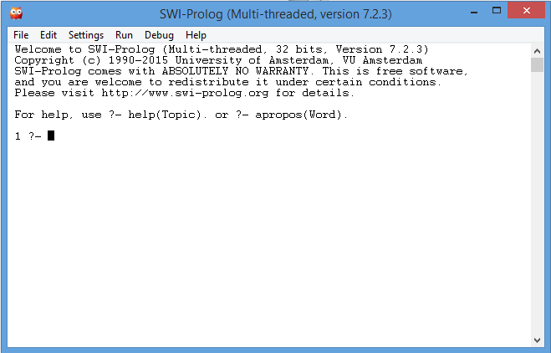

**Exercise 1**:

Try few of the examples from the Prolog lecture. Assert few facts, list the content of the KB, and retract few facts.

**Don’t forget the full stops at the end of each predicate!**

Test how the variables work. See the sample interaction window in the screenshot below.

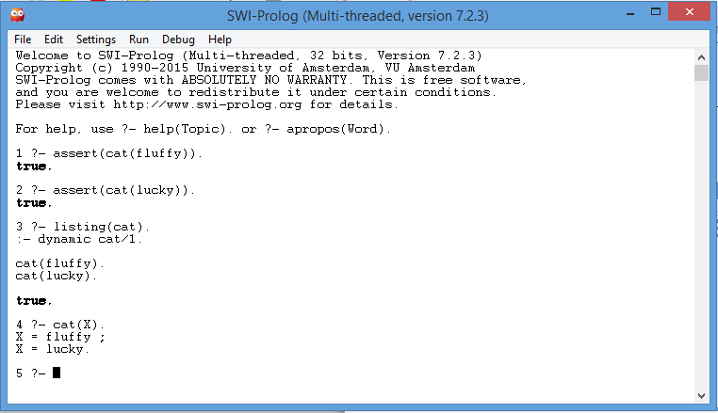

1. **Saving the knowledge base in a file**

First either type **halt**. or close Prolog, and then re-open it to clear the KB. You could also use **abolish** command to delete the predicates one by one. E.g. **abolish(cat/1)**. (Don’t forget to refer to the documentation for the exact syntax of any new predicates)

To open a new file go to File->New, enter a name for your new file, e.g. “example1” and click Save. A new window will open up where you can enter your KB. Prolog saves the files with a default extension **.pl**

You can save your files with either .pl or .pro extension (.pl also refers to Perl scripts)

**Note**: there is no need to use assert when you have your KB loaded in a file

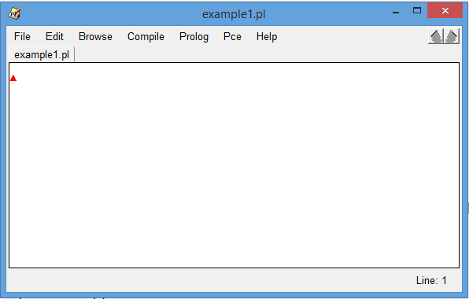

Enter your predicates and click on File->Save Buffer.

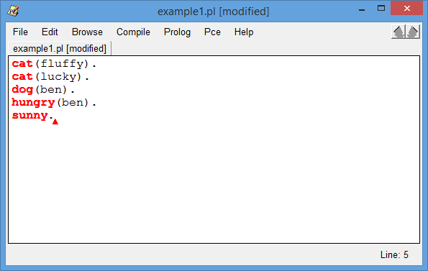

Load your file: File -> Consult , select the filename and click Open.

Then you can try some of the queries:

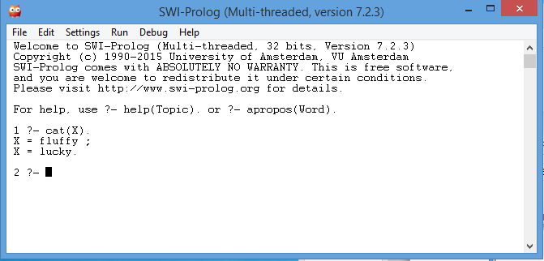

**Exercise 2:** Modify your file to add a rule that dogs chase cats. Test your rule.

Hint: chases(X,Y):- dog(X), cat(Y).

**Exercise 3:** Add couple of mice to your world, and add a rule to say that cat chase mice. Try few queries.

**Exercise 4**: Try some more of the examples from class again, but save them as a Prolog file.

**Exercise 5:**

Download the knowledge bases **kb1.pl** and **kb2.pl** from Brightspace.

Open kb1.pl, and try some queries. Don’t forget the full stops at the end! For example:

* Is ron a wizard? **wizard(ron).**
* Is ron a muggle? **muggle(ron).**
* Who is a muggle? **muggle(X).**
* Who does crookshanks chase? **chases(crookshanks,X).**
* Who chases whom? **chases(X,Y).**

Experiment with both knowledge bases and try some additional queries.

**Exercise 6:**

Download the knowledge base **kb3.pl** and examine it. Somebody is a wizard if both their mother and father are wizards. Test the rules. Expand the knowledge base to include more people.